

Dr. Joshua, Harris inc.
2019-10-21
Dr. Harris
7582 Schmidt Highway Apt. 325, Tanyaburgh, CO 93618
Phone: 3778339095
Fax: 9038449290

Re: Lauren, Clark
PHN: 1483899137
Birthdate: 18-Jan-1951
Address: 7490 Angela Pines Suite 009, Contrerasport, WA 80960
Patient number: 4040717476

To Whom It May Concern:

This is a medical letter to state the above patient is pregnant with expected delivery date of 05-Jun-2025. Hoping this information is satisfactory for your requirements.

Thank you.

Sincerely,
Dr. Joshua, Harris
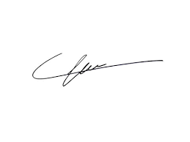
FRCS© NCMP
Clinical Assistant Professor, UBC
Department of Obstetrics and Gynecology SMH

